NAME: RAFEETH ARIFA S
REG NO: 2019504049
TITLE: PYTHON CODE
CODE:

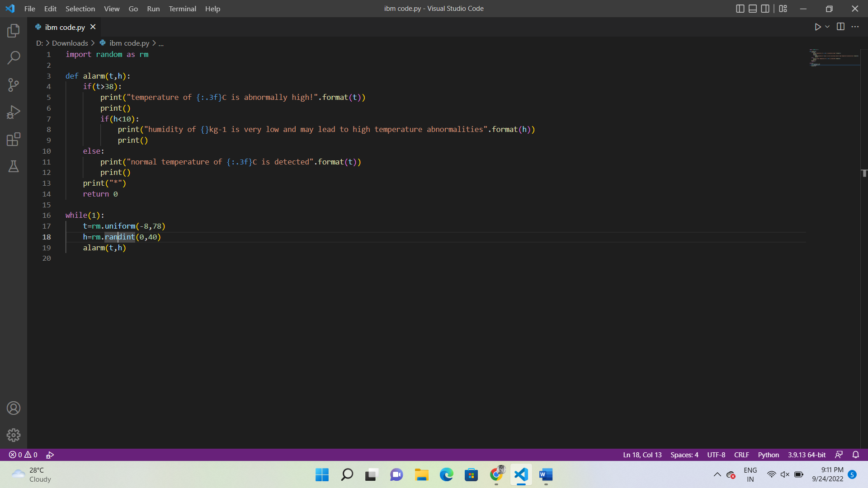
OUTPUT:
